September 2026
FX Market Structure Monthly

CHANGES IN SPREAD AND VOLATILITY FOR MAJOR MARKET PAIRS
September saw a notable increase in both spread and volatility levels across the FX market, following a relatively quieter summer and the subsequent return of trading activity. While some increases in spread and volatility levels would be expected as liquidity and participation normalised following the summer holiday period, there was also an increase in market uncertainty and some significant central bank developments that occurred during the month of September. In particular, JPY pairs had a notable increase in spreads, coinciding with the heightened volatility in the Japanese Yen around changing expectations for the Bank of Japan and the banks decision on the 18th of September to raise rates to 1.25%.

Reading the Results
On the intraday charts, the green line represents the average spread or volatility for the past 12 months, the black line represents the past three months, and the blue line represents the past month. On the daily charts, the green area represents the 95th percentile confidence interval for the spread and volatility.

SPREADS
Median spread levels increased in September for the majority, 16 out of the 23 G-10 currency pairs we monitor. However, spreads only increased for 10 out of the 23 G-10 currency pairs we monitor, when comparing them to 3 and 12 months ago. The Average Daily Spread charts highlight that spread levels were heightened across JPY currency pairs during the pre-WMR trading window, 12:00 – 16:00 GMT.

G-10 Currency Pairs: Average Hourly Spread, 00:00-20:00 GMT
Comparison over the past month, three months, and year
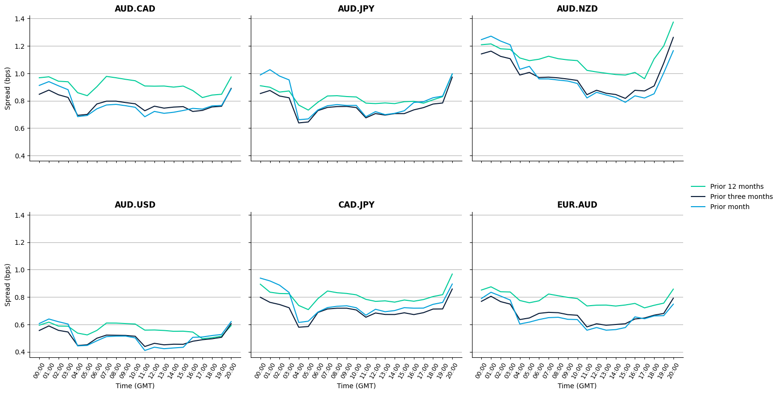
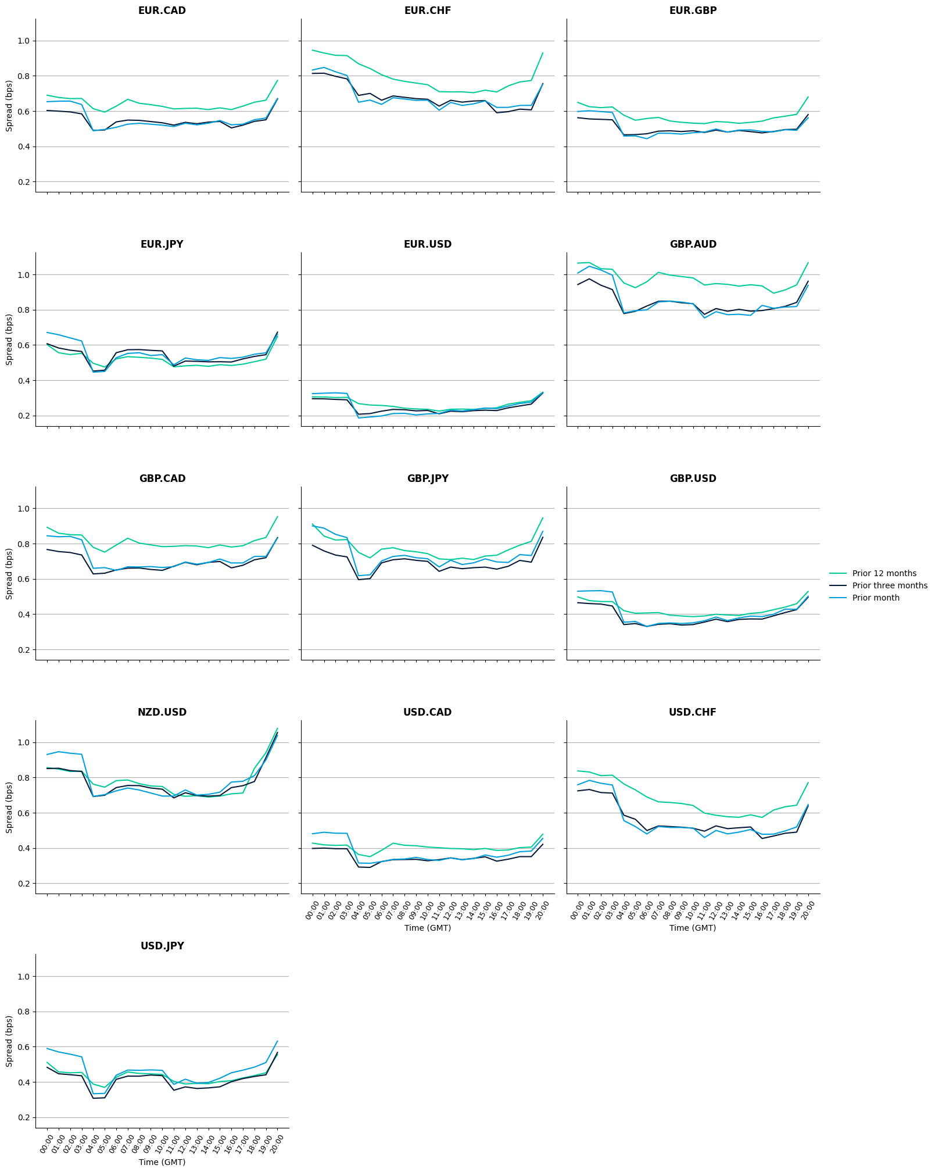

Scandinavian G-10 Currencies: Average Hourly Spread, 00:00-20:00 GMT
Comparison over the past month, three months, and year
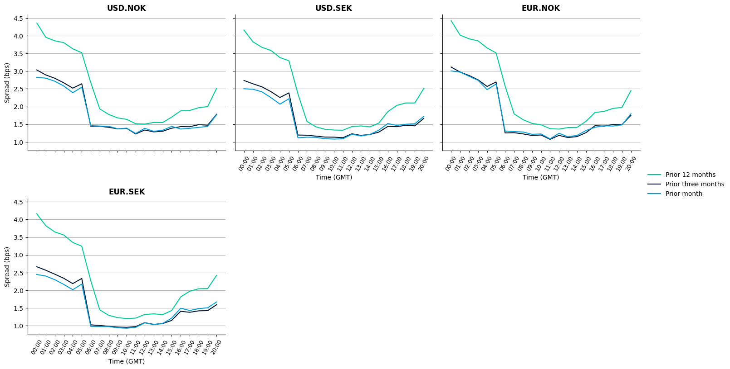
G-10 Currencies: Average Daily Spread, 12:00-16:00 GMT
September 2025-September 2026
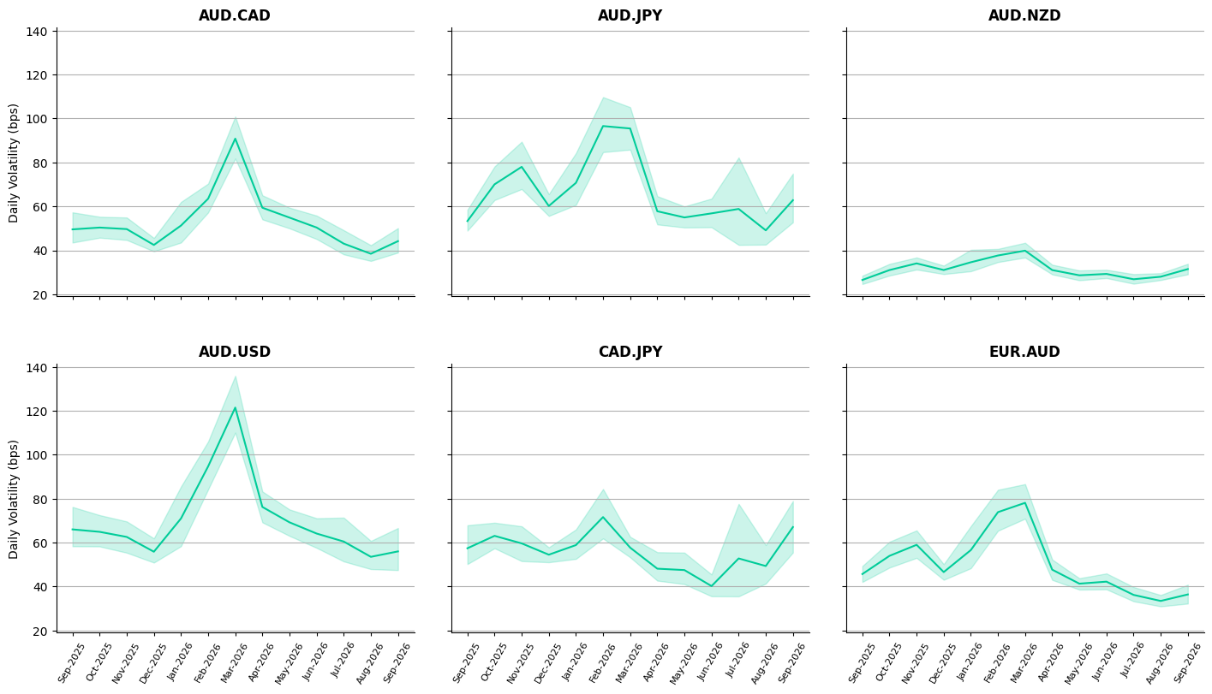
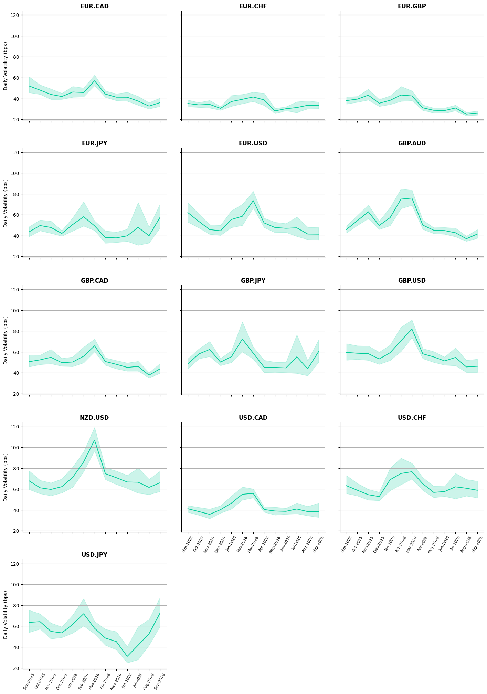

Scandinavian G-10 Currencies: Average Daily Spread, 12:00-16:00 GMT
September 2025-September 2026

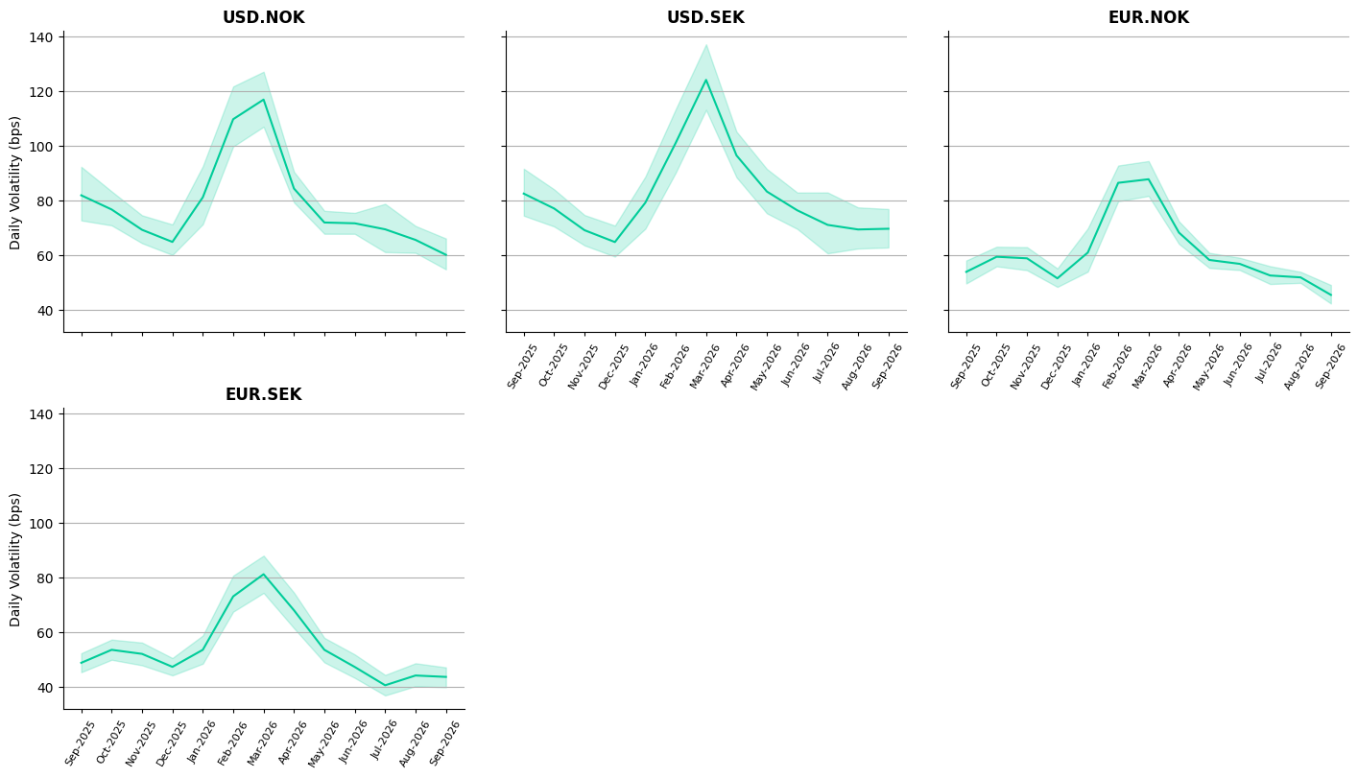

VOLATILITY
Median volatility levels increased in September for majority, 19 out of the 23 G-10 currency pairs we monitor. However, volatility only increased for 7 out of the 23 currency pairs, when comparing against 3 months ago, and 6 out of the 23 currency pairs, when comparing against 12 months ago. The Average Hourly Volatility charts show volatility levels heightened for most currency pairs, throughout the trading day.

The Average Daily Volatility charts show that volatility levels increased in September for all currency pairs we monitor, during the pre-WMR trading window, 12:00 – 16:00 GMT. On the other hand, the Average Daily Volatility charts show that September volatility levels during the pre-WMR trading window, 12:00 – 16:00, did not surpass those of historical levels. Suggesting that the heightened levels observed may represent a natural rebound following the quieter summer trading period, rather than a significant structural increase in market volatility.

G-10 Currencies: Average Hourly Volatility, 00:00-20:00 GMT
Comparison over the past month, three months and year

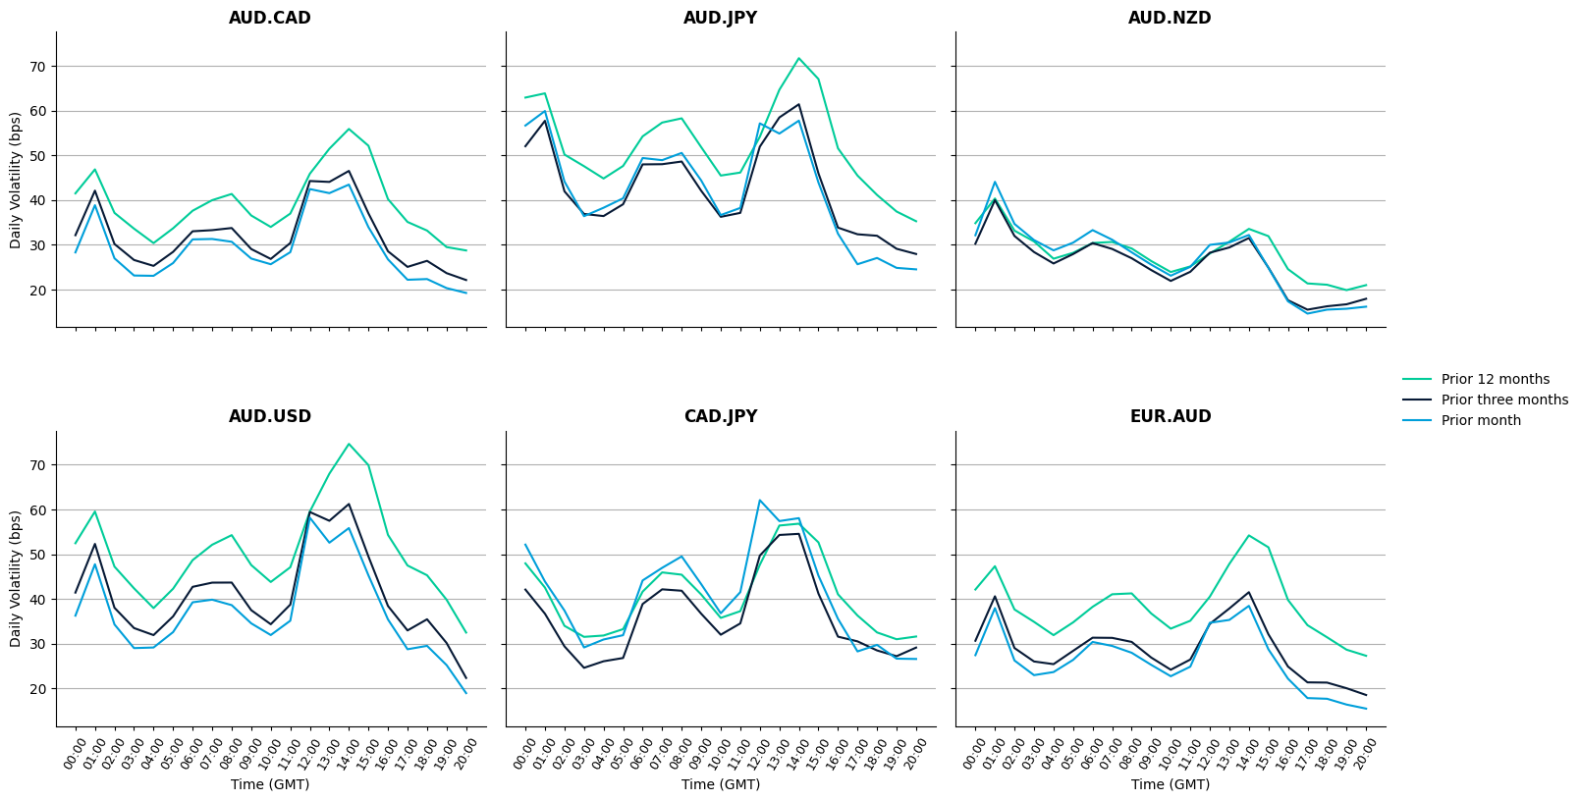

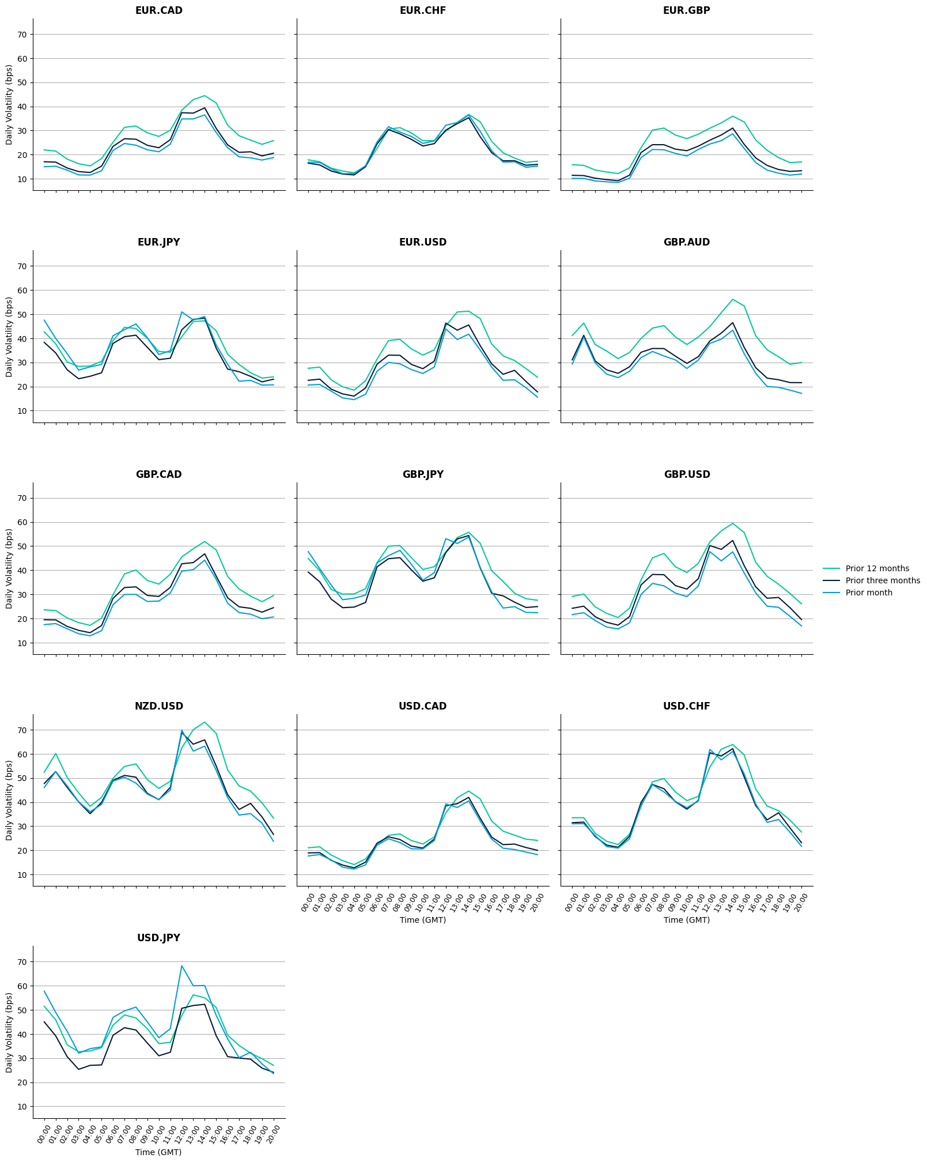

Scandinavian G-10 Currencies: Average Hourly Volatility, 00:00-20:00 GMT
Comparison over the past month, three months and year
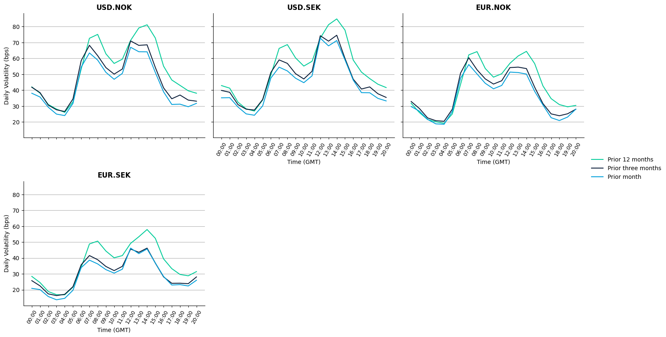
G-10 Currencies: Average Daily Volatility, 12:00-16:00 GMT
September 2025-September 2026

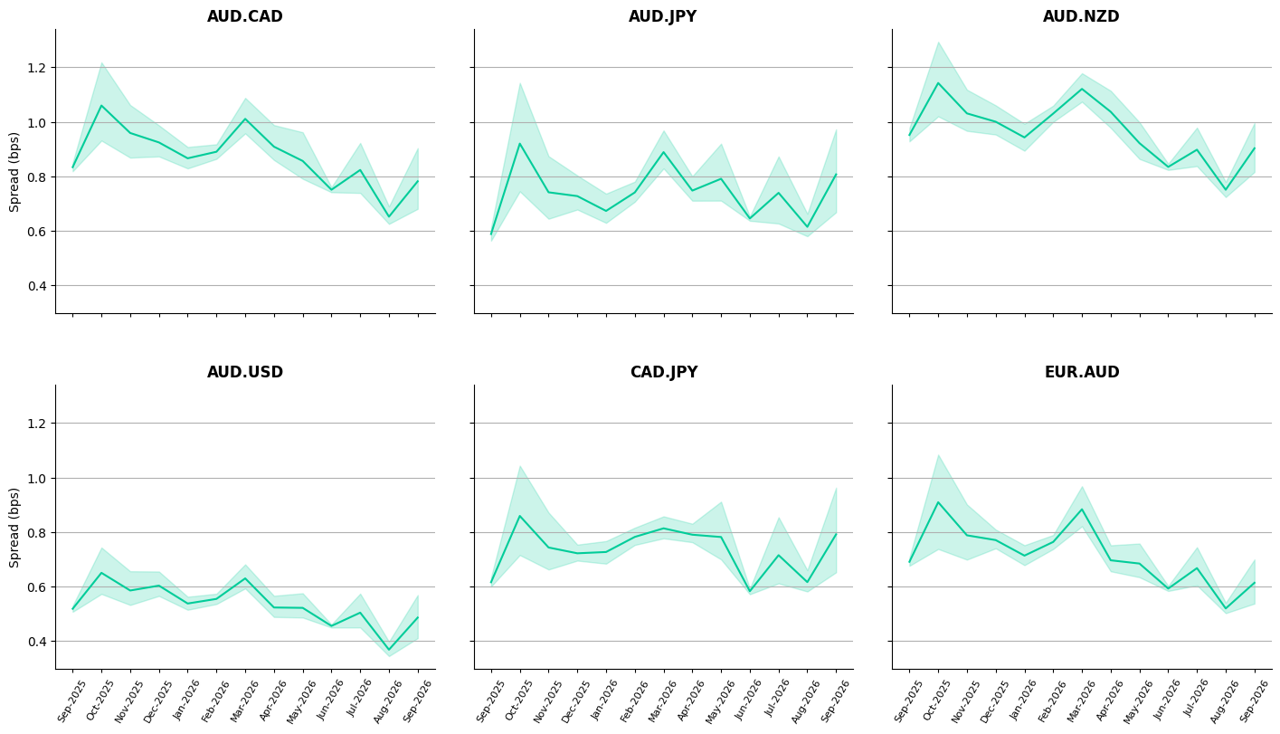
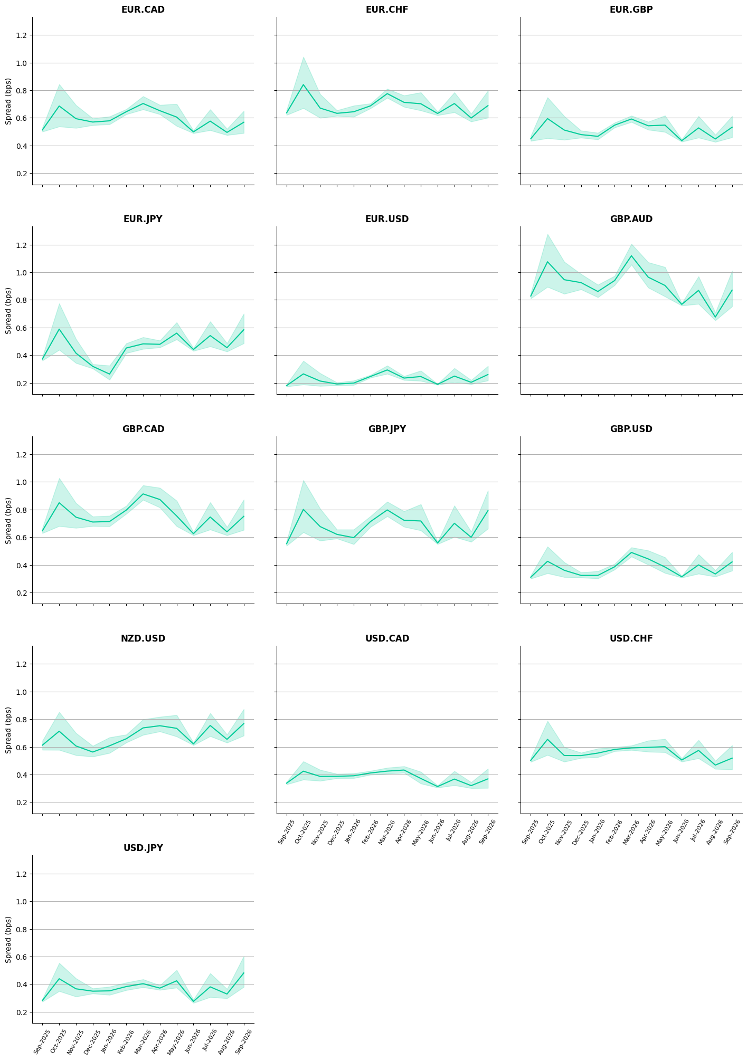

Scandinavian G-10 Currencies: Average Daily Volatility, 12:00-16:00 GMT
September 2025-September 2026

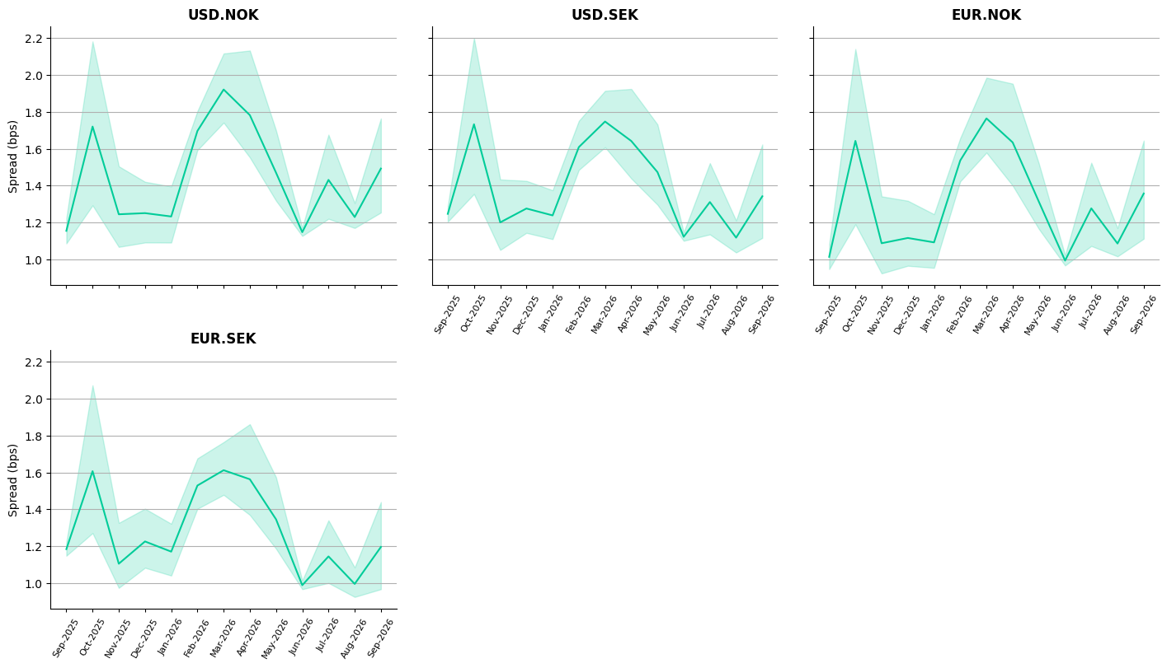

Have questions? To learn more, contact your regional Virtu Analytics representative. AMERICAS +1.866.265.4519 | APAC +852.3405.3755 | EMEA +44.20.7670.4000
analytics@virtu.com | www.virtu.com
© 2026 Virtu Financial, Inc. All rights reserved. Not to be reproduced or retransmitted without permission. These materials are for informational purposes and are not intended to be used to make trading or investment decisions, they are not intended as an offer to sell or the solicitation of an offer to buy any security or financial product, and are not intended as advice (investment, tax or legal). The information contained herein includes Virtu proprietary information and/or has been taken from sources we believe to be reliable, but we do not represent or warrant that such information is accurate or complete and it should not be relied upon as such.
Analytics products and services referenced herein may not be subject to oversight by regulatory authorities in one or more jurisdictions, including in Europe, Hong Kong or Australia, where such products and services are offered by Virtu ITG Ventures Limited, registered in Ireland No. 295549 (“VIVL”), Virtu ITG Hong Kong Limited registered in Hong Kong CE No. AHD810 (“VIHK”) or Virtu ITG Australia Limited, registered in Australia AFSL No. 219582 (“VIAU”). VIVL does not engage in regulated activity.
Securities products and services are offered by the following subsidiaries of Virtu Financial, Inc. In the U.S., Virtu Americas LLC, member FINRA and SIPC; in Canada, Virtu Canada Corp., member Canadian Investor Protection Fund and Canadian Investment Regulatory Organization; in Europe, Virtu Europe Trading Limited, registered in Ireland No. 283940 (“VETL”) (VETL is authorized and regulated by the Central Bank of Ireland), and Virtu Financial Ireland Limited, registered in Ireland No. 471719 (“VFIL”) (VFIL is authorized and regulated by the Central Bank of Ireland). The registered office of VETL and VFIL is North Dock One, Fifth Floor, 91-92 North Wall Quay, Dublin 1, Ireland, D01 H7V7; in Asia, Virtu ITG Hong Kong Limited (SFC License No. AHD810), Virtu ITG Singapore Pte Limited (CMS License No. 100138-1), and Virtu ITG Australia Limited (AFS License No. 219582).

